9 DAY ST. JOSEPH NOVENA – PART 1 (For 4/18 Church Bulletin)

The Prayer of Saint Joseph (Prayed at the end of each daily reading)
O God, who in thine ineffable providence was pleased to choose blessed Joseph for the spouse of thy most holy Mother, gran we beseech thee, that we may be worthy to have him for our intercessor in heaven whom we venerate as our protector on earth. Who livest and reignest with God the Father in the unity of the Holy Spirit, God, world without end. Amen

First Day – Thursday, March 10

The man nearest to Christ Jesus was His foster father, Joseph the carpenter.
John the Baptist saw Christ briefly near the dan and knew that his work as Precursor was over.
The Apostles lived and worked with Christ during the brief days of is public life.
But Joseph presided over the events of Christ’s Infancy, provided for Him the house that sheltered Him from birth to baptism, and was of all the men of earth the one at whose hands Jesus received most in service and love and unselfish devotion.
Born of a royal line, Joseph was a carpenter. That trade he passed on to his foster Son, Joseph was destined to immortal honors of the Church, yet no spoken word of his is recorded in the scriptures.
Still the Church with good reason cries out, “Go to Joseph.”
This injunction we confidently obey as we pray: (The Prayer of Saint Joseph)

Second Day – Friday, March 11

There is always a cause for the choices God makes.
Out of the long procession of men through history, God selected Joseph to be the husband of Mary and protector of the Savior.
Joseph’s youth was one of stainless virtue.
His young manhood was marked by deep religious faith and a burning desire to see the Savior of Israel. His was a life of honest work and of a humility that fitted him for his part in the hidden life of the Savior.
Little did he dream as he visited the synagogue on the Sabbath that someday he would be the protector of the synagogue’s God. Little did he understand that the trade of carpenter that he was learning would be the means by which he would provide food and clothing for the world’s maker, would be the trade that he would teach the creator of the universe.
Without knowing what it was that he was getting ready for, he gave to his simple jobs the full devotion and the full strength of a character of a simple, honest man.
In these ordinary ways did he fit himself for the extraordinary assignment that God would give him.
Remembering this splendid man, who walked the simple ways we pray: The Payer of Saint Joseph.
Third Day – Saturday, March 12

Tradition has it that Joseph had taken the vow of virginity, thus renouncing the right to marriage. At any rate he lived a life of purity. He was stainless among men and pure in the sight of God.
But God in His providence had greater designs for Joseph than mere abstinence. He chose Joseph, the just man, for the delicate mission of sheltering Mary’s virginity and at the same time being her loyal spouse and guardian of the Incarnate Son of God.
Legend tells us that he was selected by a miracle: The barren rod that he held in his hand blossomed with lilies. Perhaps. But surely his soul was bright with joy when he knew that God had given him to be the partner of his life the rose of Sharon the stainless lily of Israel, the flower among all the flowers in God’s garden.
He accepted his bride and his new responsibility with the determination to make her happy, to keep her happy, to keep her safe, and in her company to carry out whatever were God’s plans for their future.
So Joseph and Mary were married, and they established the holy house of Nazareth. There they lived most exemplary lives.
To this strong and pure protector of Mary they pray: The Prayer of Saint Joseph

9 DAY ST. JOSEPH NOVENA – PART 2 (For 4/25 church bulletin)

The Prayer of Saint Joseph (Prayed at the end of each daily reading)
O God, who in thine ineffable providence was pleased to choose blessed Joseph for the spouse of thy most holy Mother, gran we beseech thee, that we may be worthy to have him for our intercessor in heaven whom we venerate as our protector on earth. Who livest and reignest with God the Father in the unity of the Holy Spirit, God, world without end. Amen

Fourth Day – Sunday March 13

Wedded to the loveliest of brides, entering marriage with strong ideals and a trust in God’s provident care, Joseph had a right to expect love and security that come with consecrated marriage.
While marriage for him was the beginning of a high honor, it was also the beginning of a new pain. While it added to his royal dignity, it was also the occasion of poverty, patience, exile, obscurity, confusion and wonderment.
For at once he found that his virgin bride was with child. What could this possible mean? He wanted to think her stainless, but what of this clear evidence? He was confused and bewildered. And while it was distasteful to a man of his simple reticence, the law of his people demanded that he put her away.
Since Mary herself did nothing to enlighten him (for she was committed by God t secrecy his confusion gave way to grave doubt, and doubt in turn gave way to firm, honorable resolve to take action.
Hat a period of suffering and suspense this must have been to Joseph. In His own good time, God would reveal the wonders of the incarnation of His Divine Son. But to prepare his soul for so great a miracle, God chose to cleanse his heart in suffering.
Remembering his trial and suffering, we pray: The Prayer of Saint Joseph

Fifth Day – Monday, March 14

Pain and patience in the service of Christ and His Mother soon turn to joy.
The visit of the angel brought an end to Joseph’s problems.
The Child who the lovely Mary carried was the Son of the Most High. He had no earthly father, for God Himself was His Father. The Holy Spirit had wrought the wonder in Mary’s body.
Over Joseph there came in a rush the realization of what his marriage meant.
He among all men of earth was to be the guardian of the Mother of the Savior.
Upon him would rest the responsibility to protect the Christ Child, to provide His home, to watch over His childhood, to lead Him into the safe maturity that would be a prelude to His public life.
The home? Joseph had only the house of the carpenter to offer. The food of the Son of God would be plain. The clothes He wore would be those of a laborer’s child. But Joseph silently vowed that the Christ should never want for a heart to love Him, for hands to serve Him, for feet to run His errands, for a back to shoulder whatever weight God would let him bear. Joseph and Mary smiled upon each other and together waited for the coming of the Son of God, the Savior of the world.
To Joseph, guardian of Mary and protector of the Infant Savior, we say: The Prayer of Saint Joseph

Sixth Day – Tuesday, March 15

To us Christmas is a day of uninterrupted joy.
To Joseph it was a day of the brightest light and the deepest shadows: a blazing sky and a chilly cave; the presence of angels and the cold shoulder of the villagers; faith and sorrow; intensest joy in the Infant and grief that he could give the Infant only a stable and straw and his ineffectual service.
The story of Joseph and Christmas is dearly familiar to us.
It was decreed that they leave the comfort of home and journey to Bethlehem. The doors of the crowded inns were slammed in his face. He quested through the night until he found the cave and prepared it for his bride and for the coming Child.
His was the joy of hearing the song of the angels and watching the procession of the first adorers. His was the pain of seeing Mary shiver in the cold darkness and of remembering that they had been forced to leave in Nazareth the cradle that he had made with such loving care.
He was the first sentry in the court of the new king, His first man-at-arms, s prime minister, His treasurer, the faithful disciple of the master, who had yet to speak His first word.
To Joseph at Christmastide we say: The Prayer of Saint Joseph

Seventh Day – Wednesday, March 16

Compared to the powerful and important Herod, Joseph was in the eyes of his times a nobody.
Joseph was in the eyes of his times a nobody.
Yet as this faithful carpenter and saint made smooth the ways of his Lord, worked for His comfort, and knelt to adore Him, Herod plotted the destruction of this Child, whom he looked upon as a possible rival for his throne.
Herod had tried to turn the Magi into messengers of death, but these wise men had on a warning from God, through the star-lighted night found their way to the king. Failing this, Herod sent his soldiers out to kill the Child and end the threat to his brief ad pitiful power.
Another visit of an angel…and Joseph is moving through the night, leading the ass that carries the sacred burden of Mother and Child.
Eyes alert for danger, staff gripped tightly against possible threat, feet tirelessly striding forward, a few coins in his purse, his locked shop left behind him, Joseph travels the glorious and ignominious road to exile.
But God had chosen well when He chose this protector of Mother and on. The journey was safe, the exile comfortable, and the return happy and secure.
To Joseph, guardian of Jesus and of Mary in danger and in exile, we say:
The Prayer of Saint Joseph.

Eighth Day – Thursday, March 17

Wonderful things have happened in the long annals of mankind, but none have been more wonderful than what occurred in the little house and shop of Joseph in Nazareth.
The earnings of a laborer provide the food for the creator of heaven and earth.
Into the little carpenter shop comes the young Jesus, apprenticed to a trade. Joseph guides the hands that guided the course of the stars; he teaches the maker of sun, stars, and planets the craft of making tables and chairs for peasants and yokes for oxen.
The Trinity looks down to the lovely trinity of heart – Father, Son, and Holy Spirit beautifully mirrored in Joseph, Mary, and Jesus.
Modern Christian homes receive their design and pattern from this model.
Modern Catholic marriage is here given its lovely example.
Childhood learns obedience as the young Jesus obeys the commands of his parents.
The hearts of Mary and Joseph create a union close and dear and intimate and utterly beautiful; together they live and think and plan and work for the Child, who has been given into their keeping.
Theirs was a beautiful family.
Remembering the happiness of Joseph in Nazareth, we pray:
The Prayer of Saint Joseph.
Ninth Day – Friday, March 18

Death in the days before Christ was often frightening, often terrible.
It was left for Joseph to show us for the first time the perfect way to die.
Graciously God let him know that his work was done. Jesus was almost ready to enter His public life; in that the humble carpenter would play no part.
He obeyed the voice of God in death as he had obeyed that voice in life. But for him the voice had no terrors.
As Joseph lay on his bed, Jesus and Mary were close to him. His head rested on the virgin breast of his untouched bride. His hand rested in the firm grasp of his foster Son. Jesus was speaking gratefully of what Joseph had done for Him. Mary was saying a loving thank-you. His thoughts were being lifted up…and up…and up toward the heaven that lay ahead and the glory that comes to those who have done their simple duty well.
Jesus and Mary followed their beloved protector to the grave.
In his place in glory the whole Church has sought him, called him its faithful guardian, and known that from his powerful intercession favors past counting fall upon the world of men and women, whom he regards as his beloved sons and daughters.
To Joseph in Heaven we say: The Prayer of Saint Joseph.

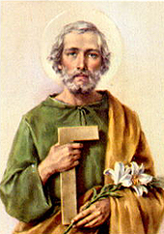
Second Day

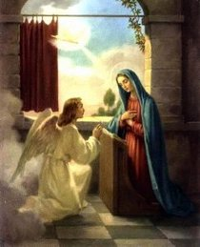
Fifth Day

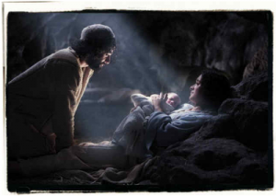
Sixth Day

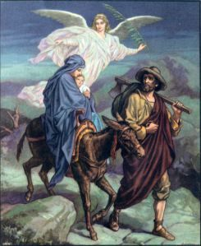
Seventh Day

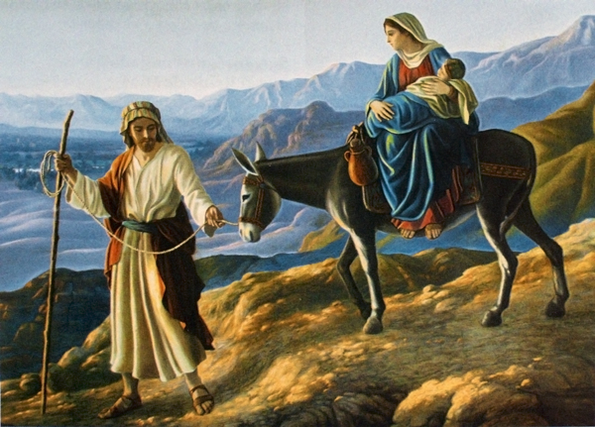
Seventh Day

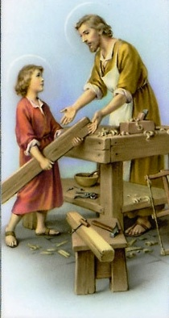
Eighth Day

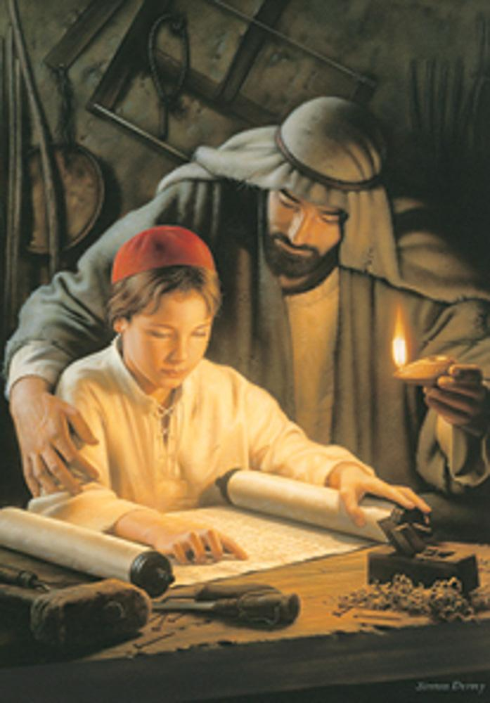
Joseph teaching Jesus

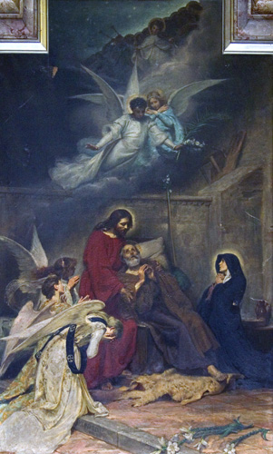
Ninth Day (Death of Joseph)

